G I F T

Growing Innovation For Teaching

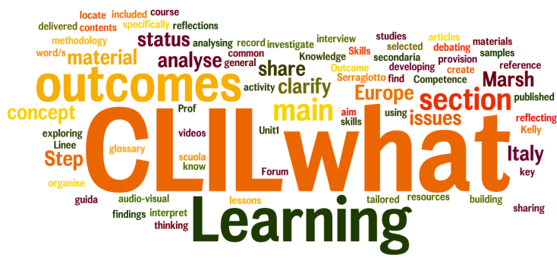

Learning Outcomes

Knowledge:
- to know the main contents and issues of CLIL
- to know the main reasons of CLIL adoption.
- to know relevant information and experiences on CLIL lesson planning
Skills:
- to locate, organise, record and share general findings on CLIL in the selected material
- to investigate CLIL benefits for students and school staff.
- to detect, classify and record material designed to help CLIL teachers practically and effectively teach different contents through the medium of English;
- to work out a CLIL learning outcome unit pattern to be applied to a variety of subjects across the curriculum, also during the mobility experience.
Competence:
- to analyse and interpret the status of CLIL provision in Europe and Italy
- to infer and make conclusion about CLIL strength points.
- to identify CLIL positive applications in learning situations and adopt them in in Units of Learning Outcomes.

